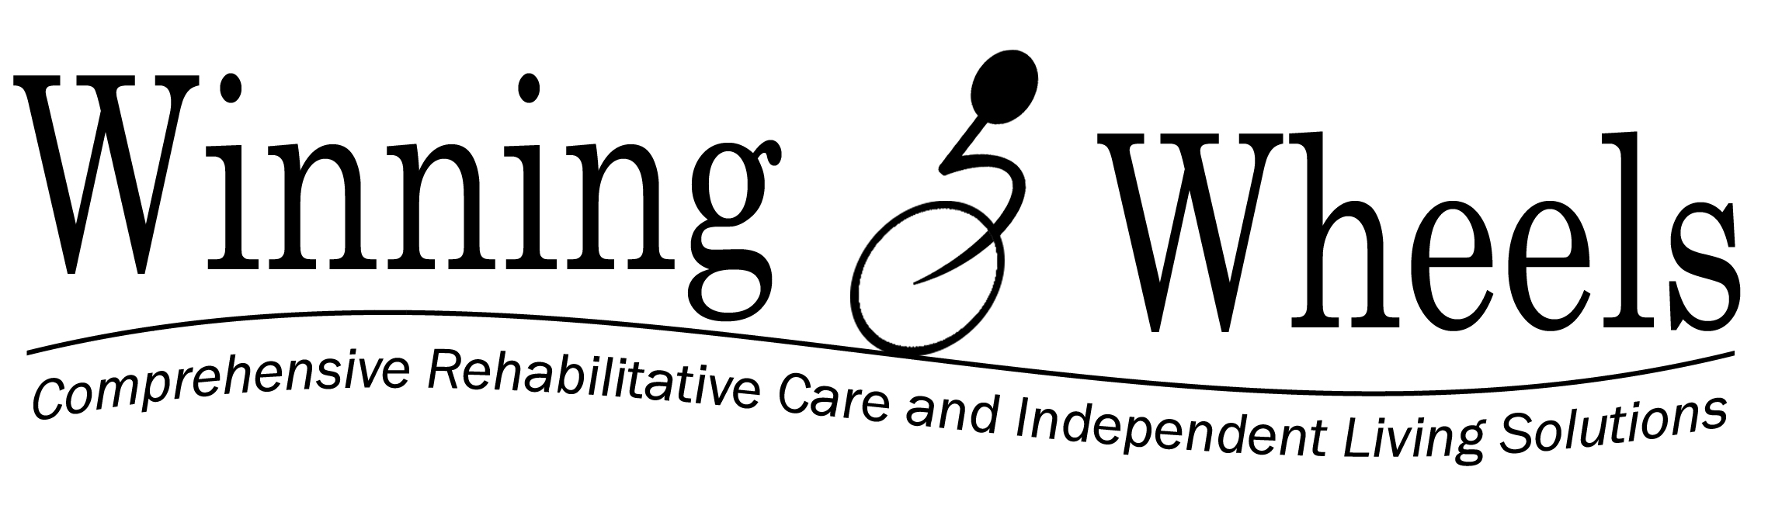

Consent to Photograph / Video

I, __________________________________, authorize Winning Wheels' designated person(s) to
Resident Name
take photographs of me for the purpose of publicity (i.e. newsletter, photo boards, website, scrapbooks, video, etc.).

I may revoke this consent by providing written notification to the Admissions Coordinator or Administrator.

Signed:

____________________________________________ ______________________________
Resident / Guardian Date

____________________________________________ ______________________________
Witness Date

7/2016

